Bug Report for Student Registration Form

|  |  |
| --- | --- |
| Project Name | Student Registration Form |
| Client Name | Levitica Technologies Pvt. Ltd. |
| Reference Document | FRS |
| Created by | Sumanth Bodduna |
| Created Date | 15-04-2024 |
| Approval Date | TBD |

Bugs List:

1.Incorrect Title Name and Portfolio for Application.  
2. Name of the fields Should Start with Capital Letters.  
3. Input Fields are Accepting Invalid Data

4. Alignments of Input Fields and Spaces between Input Fields are Not Proper

5. All States are Not Visible and State Names are Incorrect

6.After Selecting State All Districts of Particular State are Not Visible

7.Submit Button is Not Working

***Incorrect Title Name and Portfolio for the Application***

1.Enter URL : <file:///C:/Users/Sumanth/Downloads/Manoj/Manoj/student%20form%20registration.html>

2.User will Land on the Registration Form Page

3.Observe the Title Name for the Tab is not Apt title

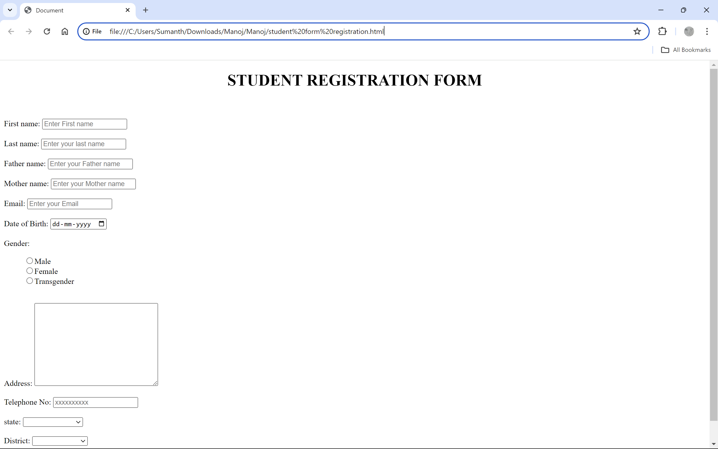

***If Particular Field has Two or more Words Each Word Starts with Capital Letter***

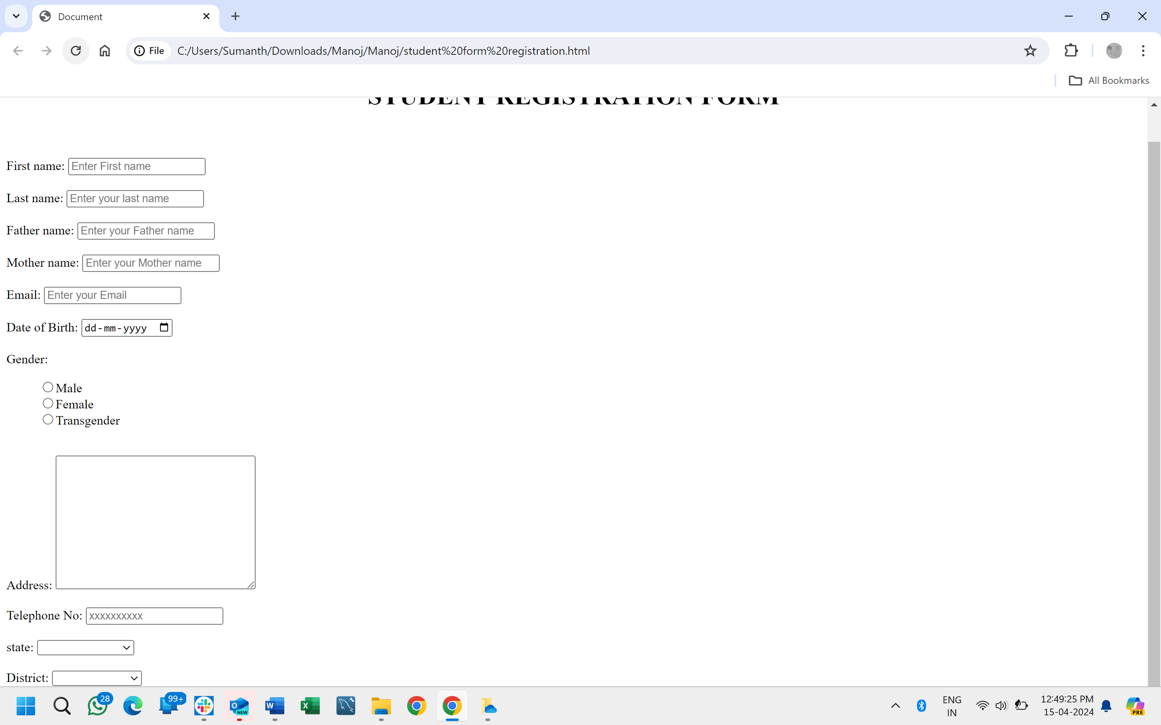

***First Name Field Should Not Accept Special Characters and Numerical.***

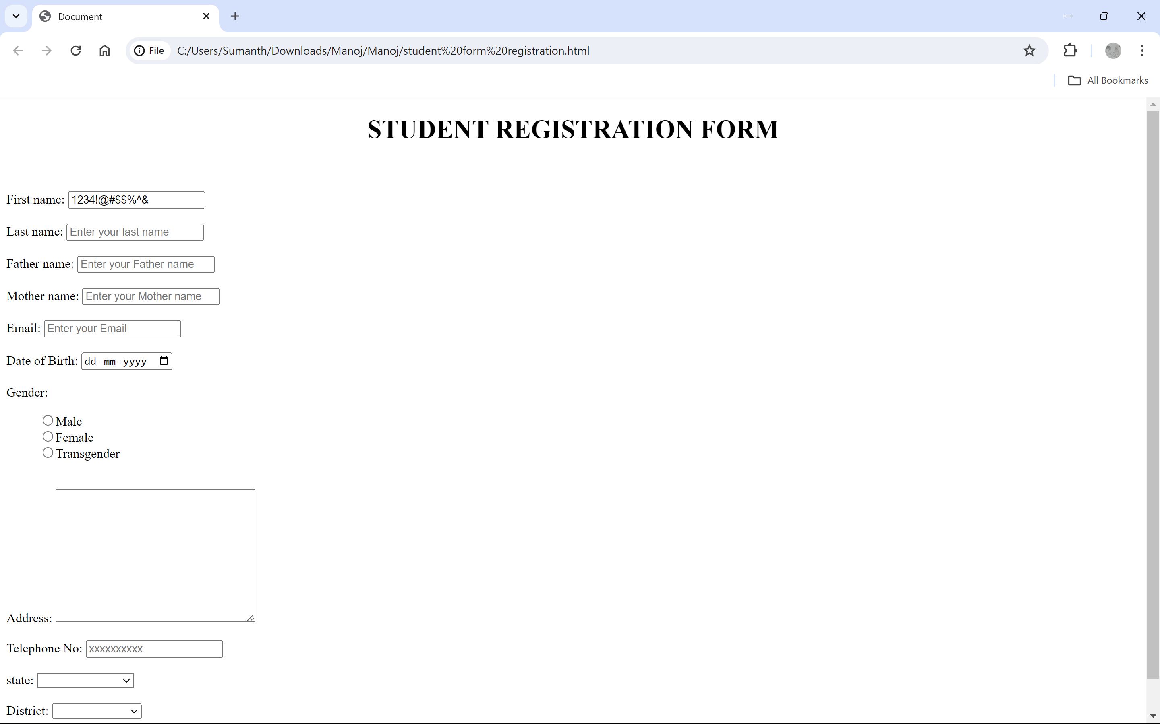

***Last Name Field Should Not Accept Special Characters and Numerical.***

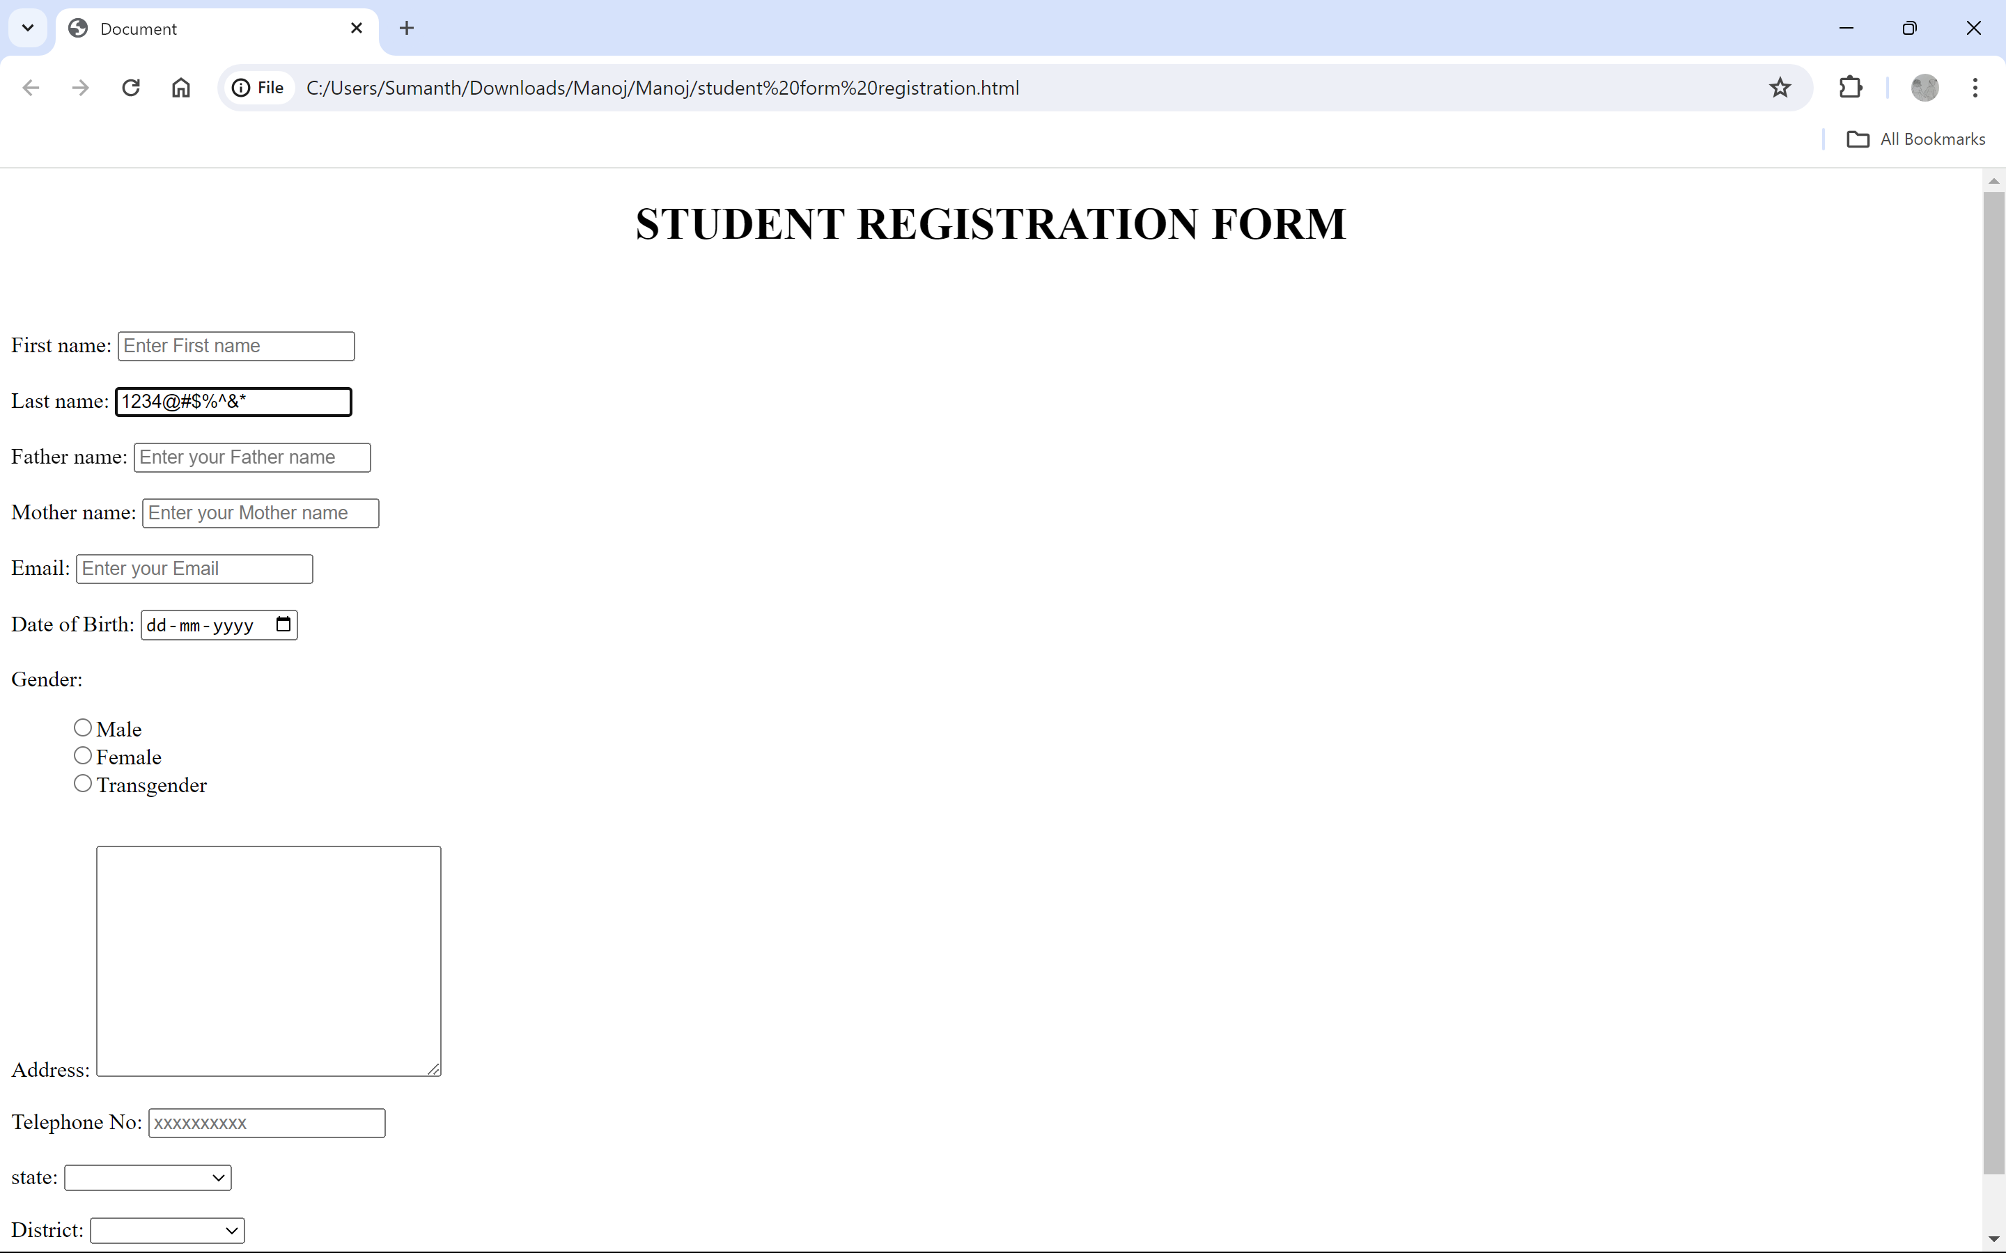

***Alignments of Input Fields and Spaces Input between Fields are Not Proper.***

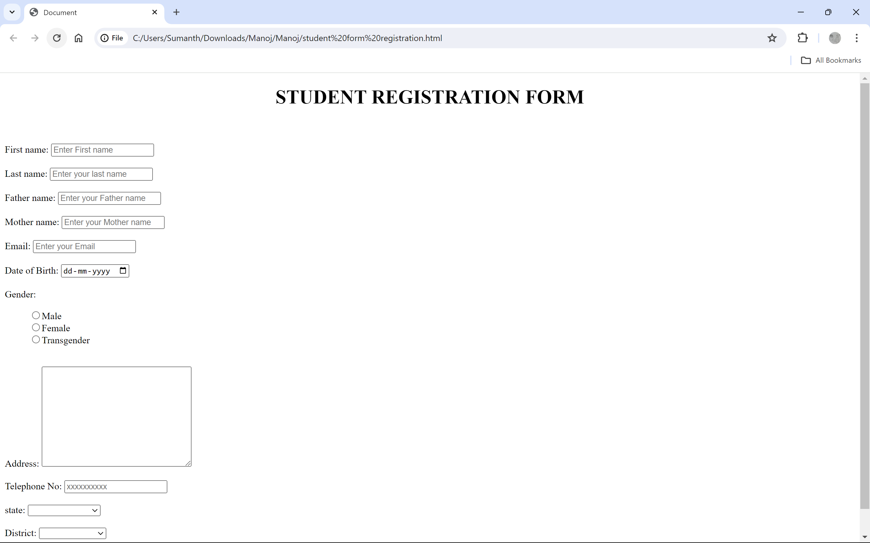

***Father Name Field is Should Not Accept Special Characters and Numerical.***

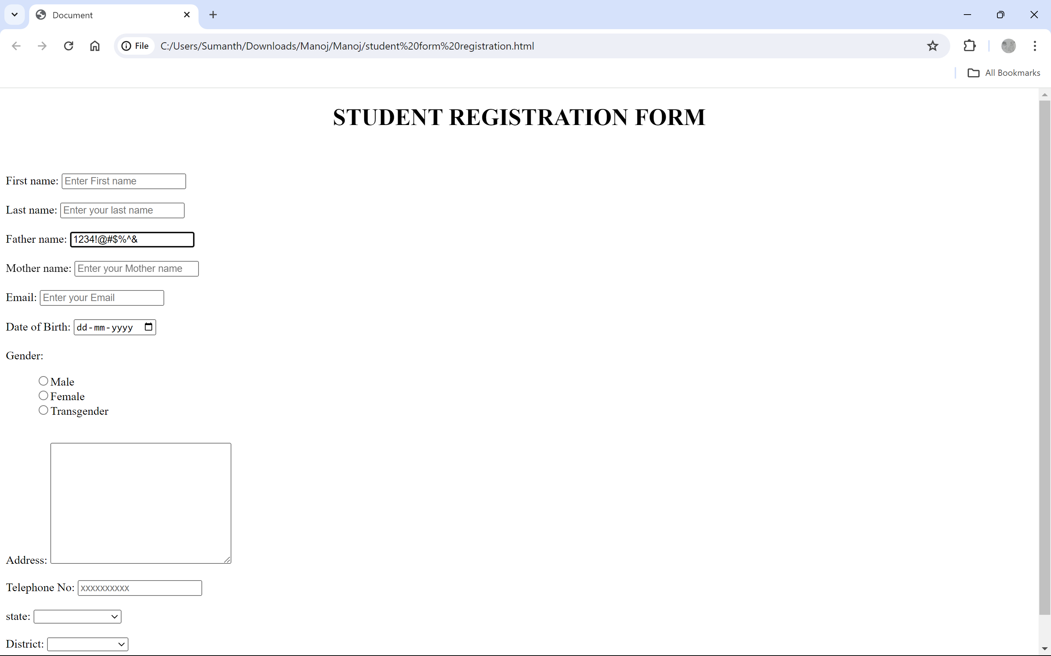

***Mother Name Field is Should Not Accept Special Characters and Numerical.***

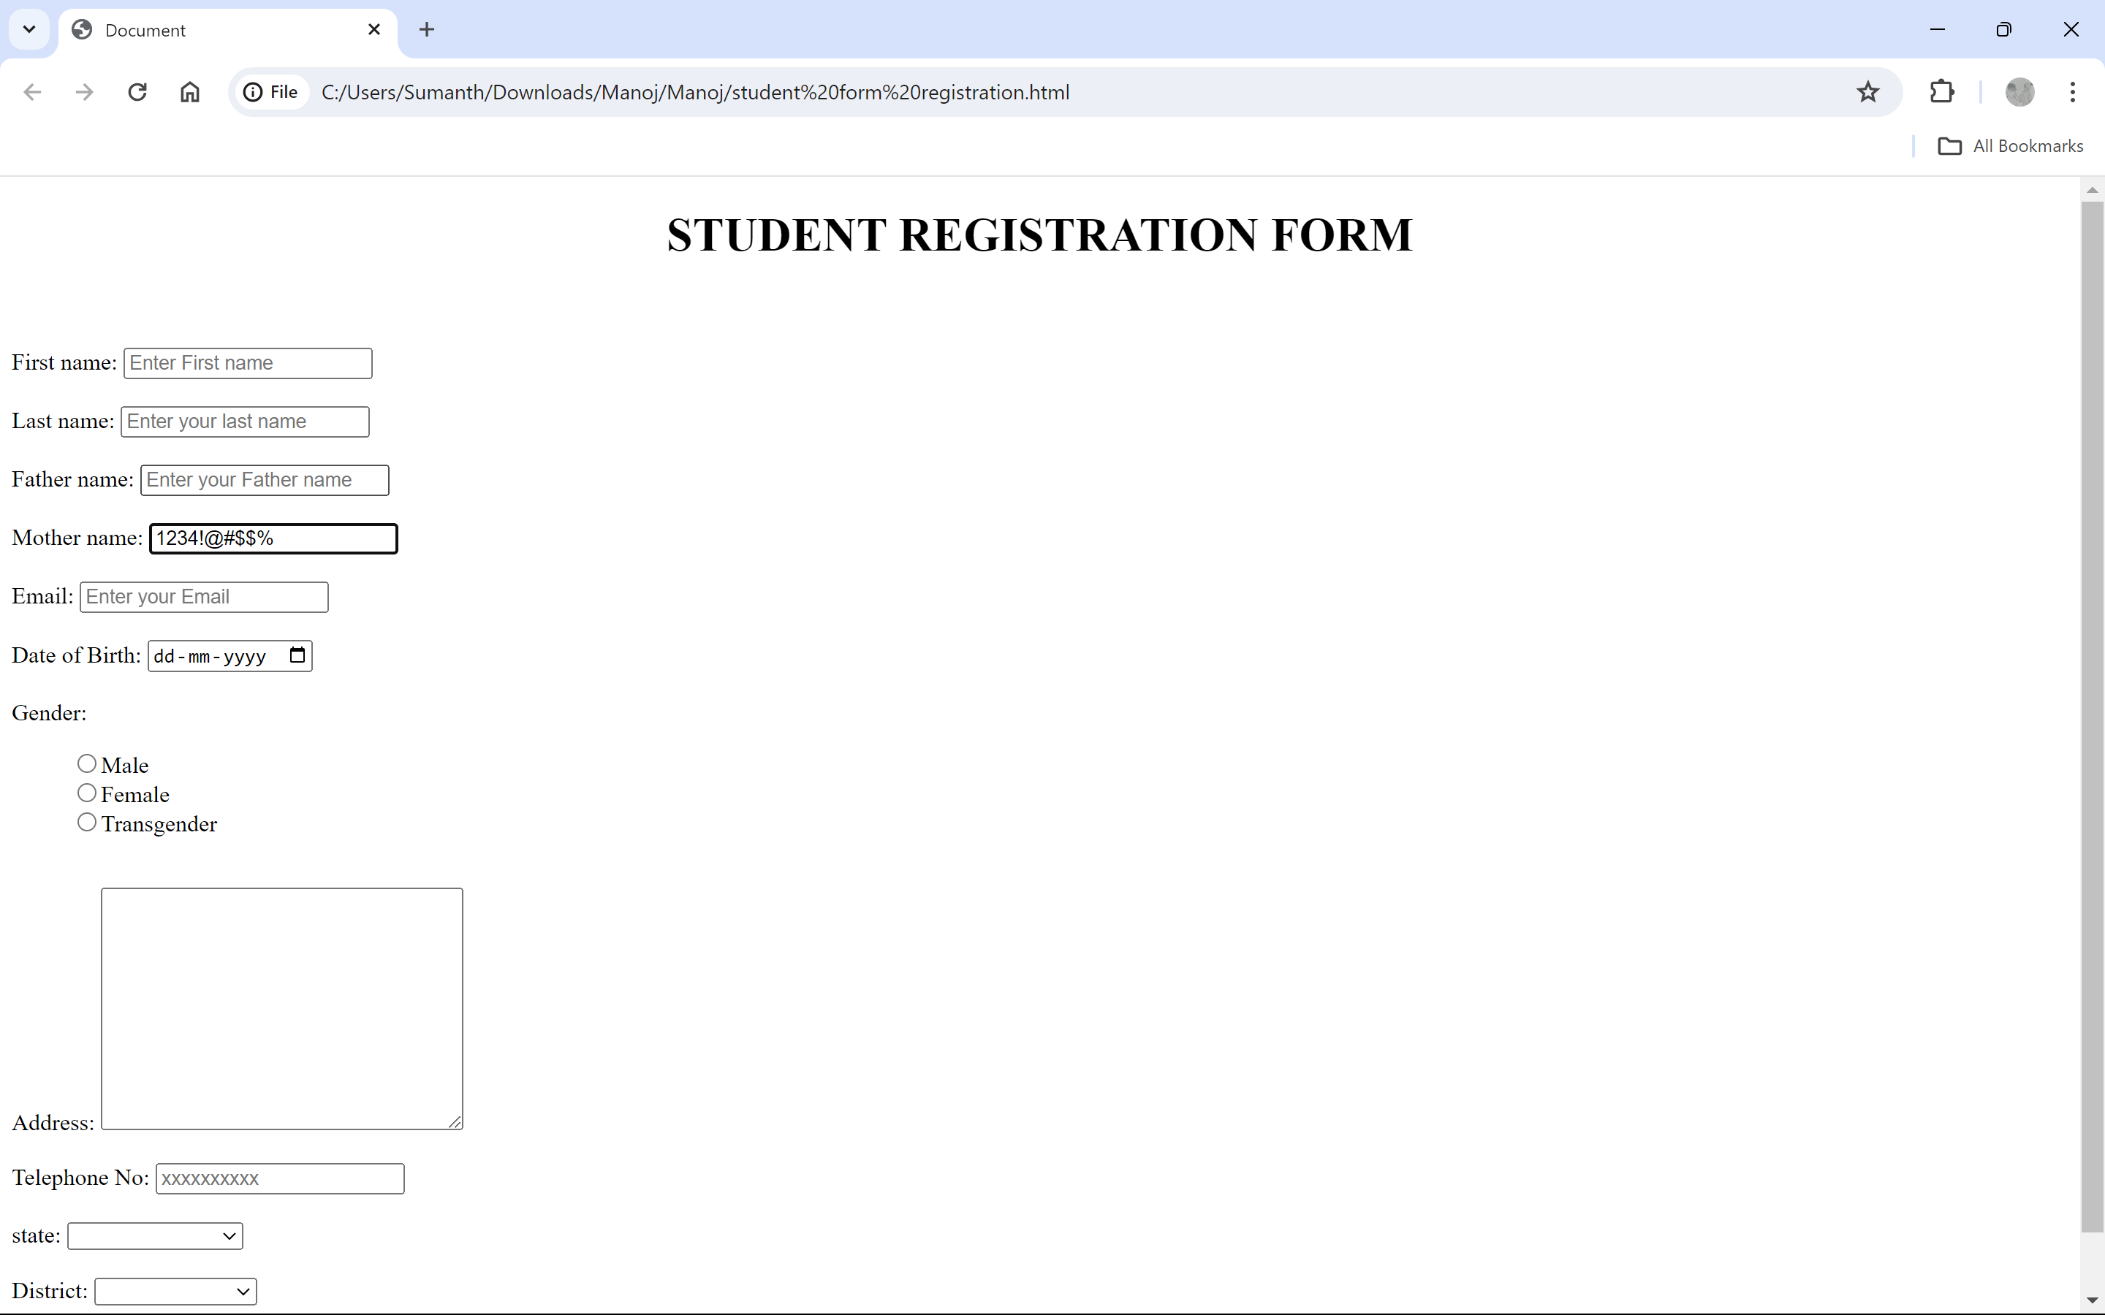

***Email Field Should Not Accept Spaces***

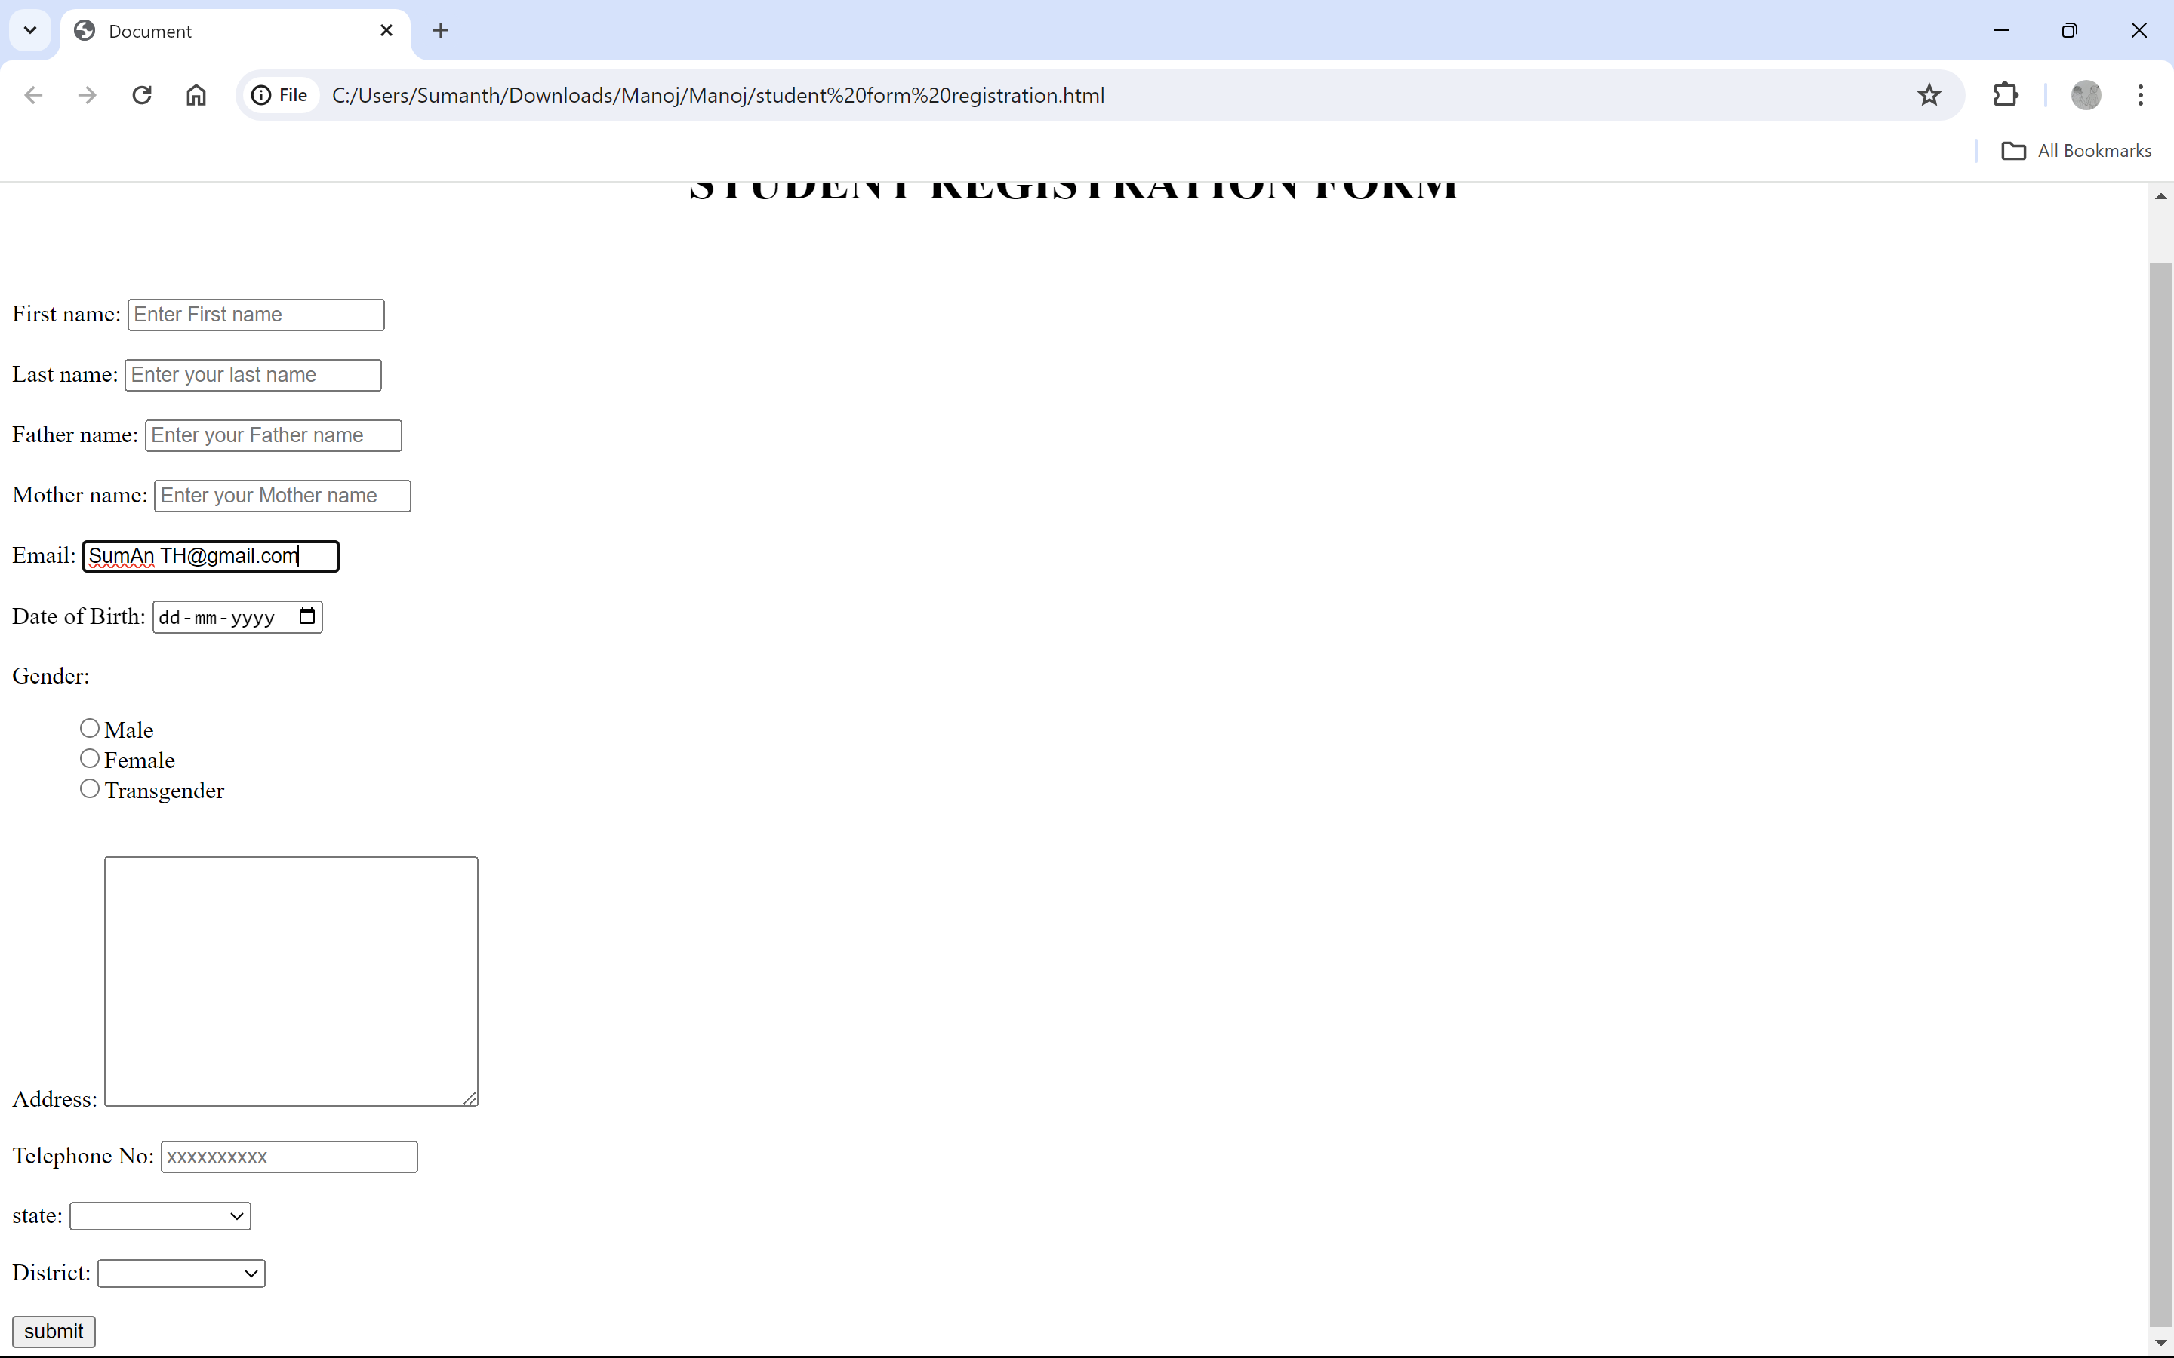

***Date of Birth Field is Should Not Accept Future Dates***

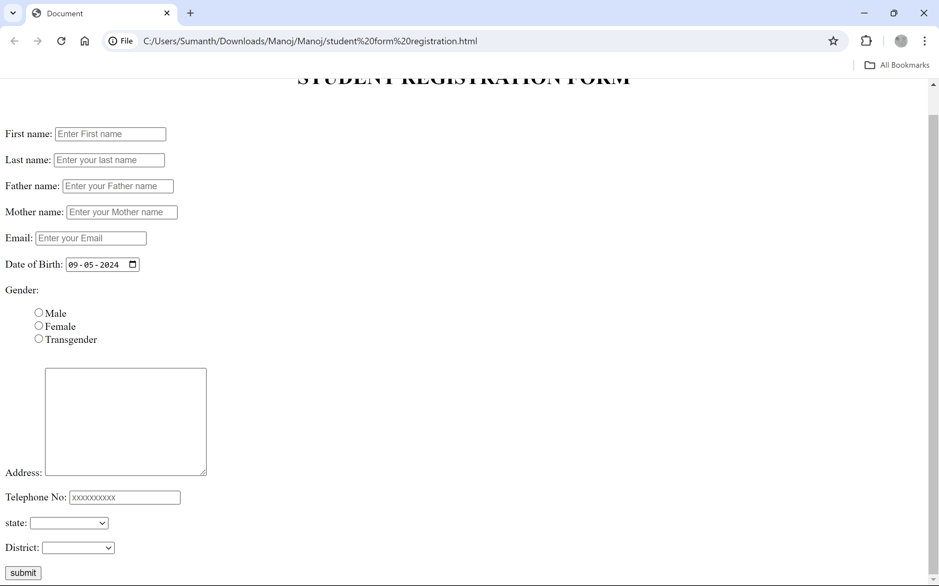

***Date of Birth Field Year Should Not Accept More Than Four Digits***

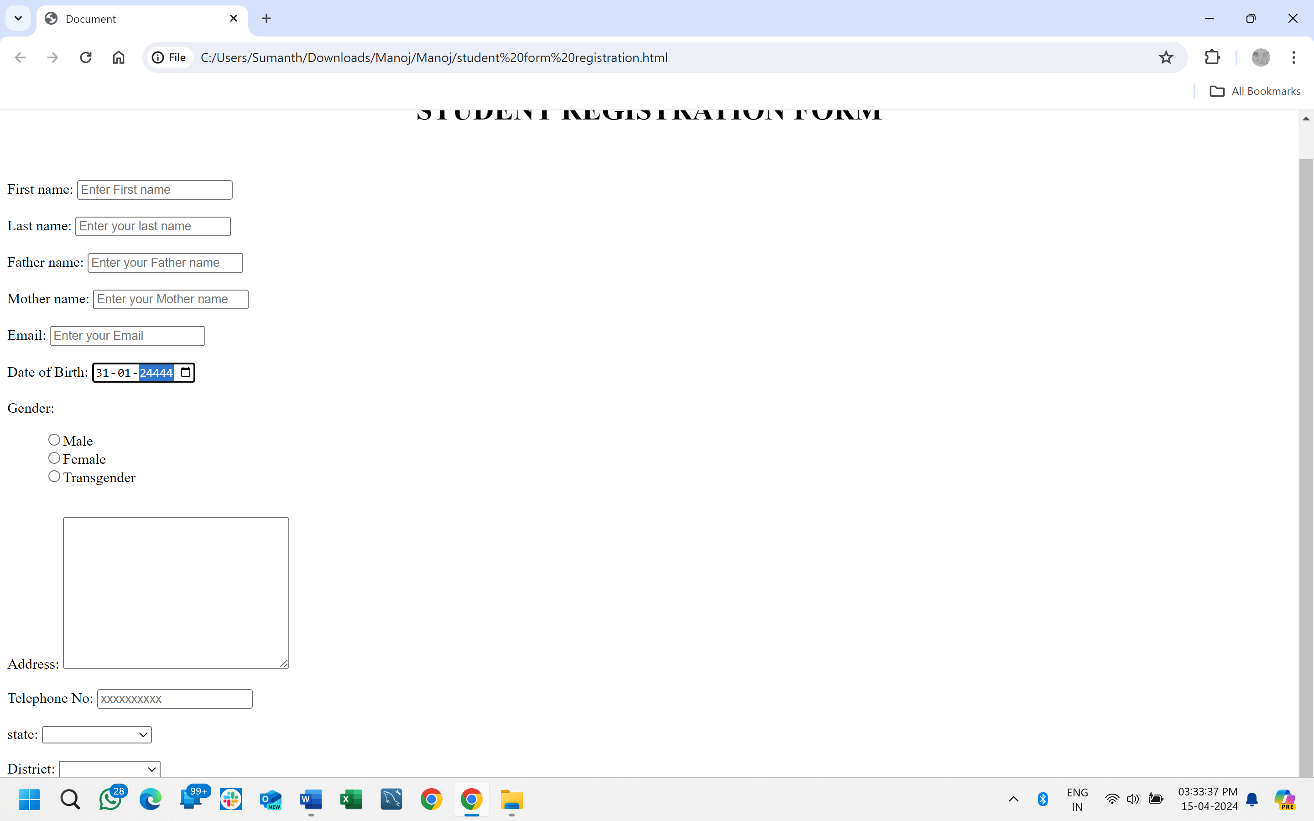

***Telephone No Field Should Not Accept Alphabets and Special Characters.***

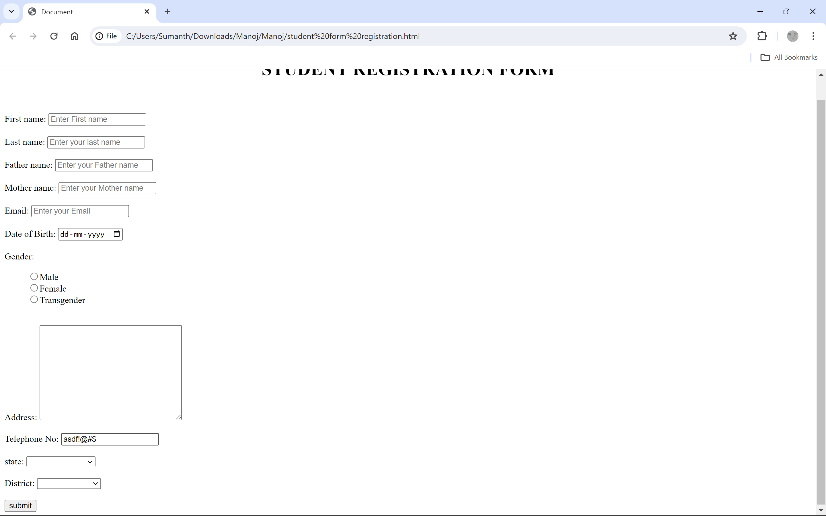

***All States are Not Visible and State Names are Incorrect***

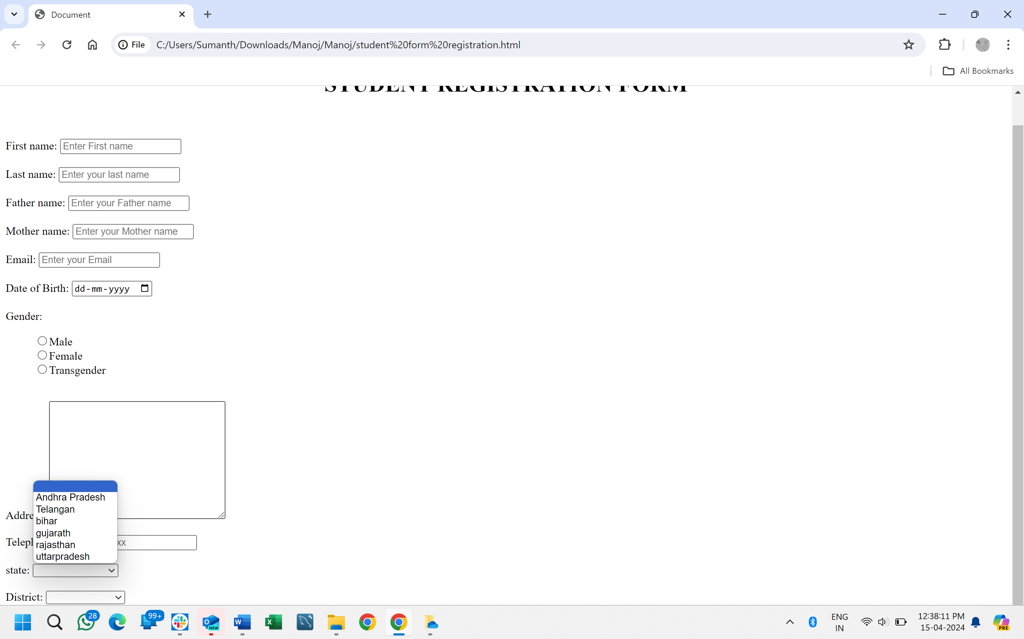

***After Selecting State All Districts are Not Visible***

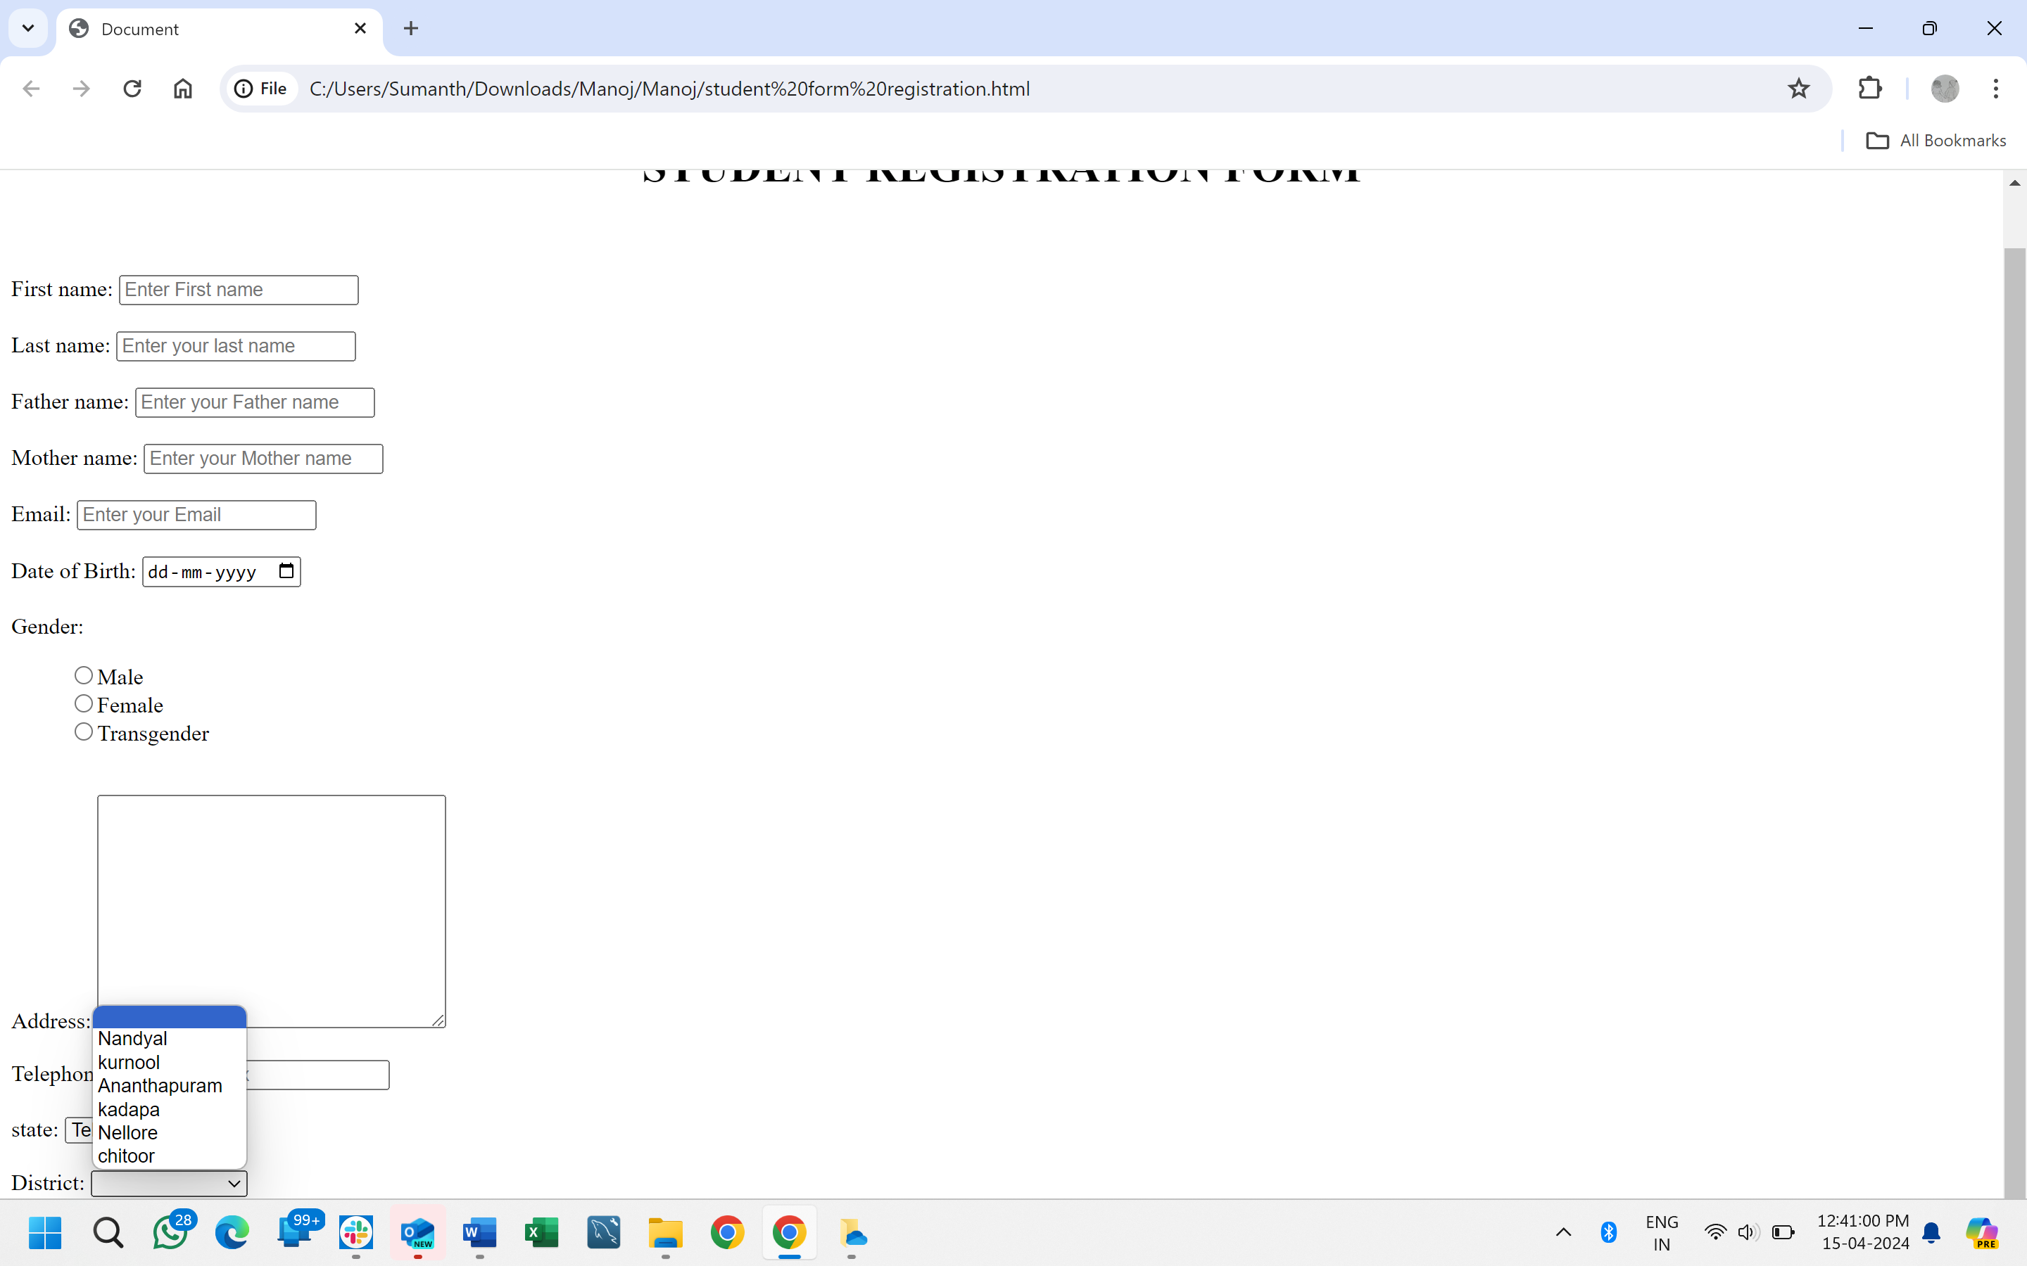

***Submit Button is Not Working***

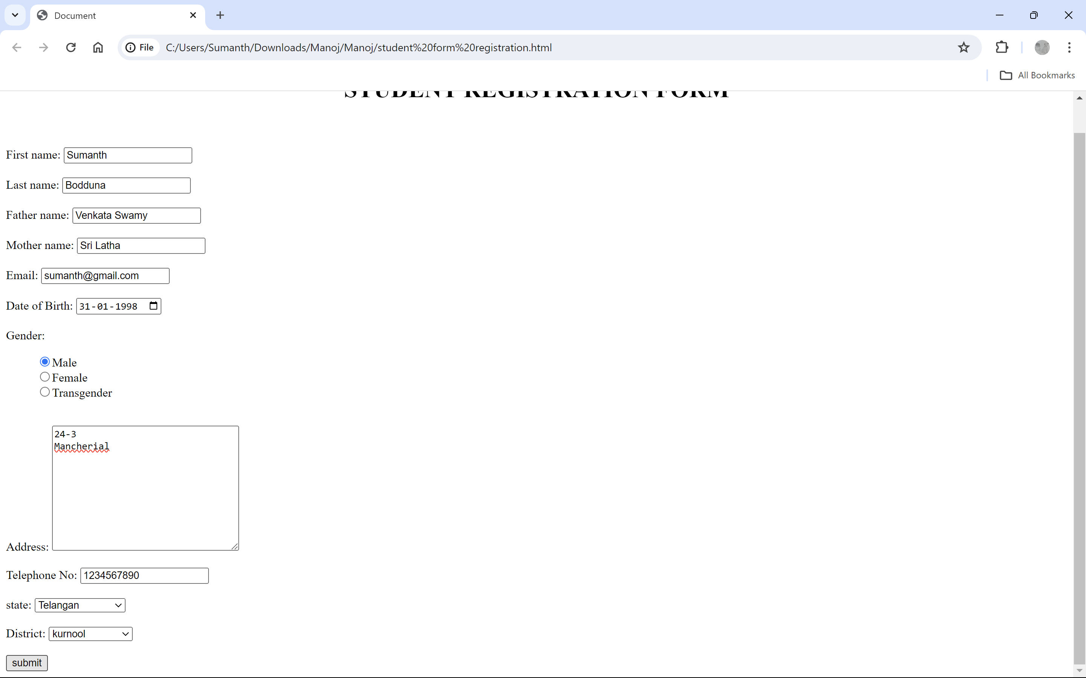

**Suggestions**

* After filling out the Application User is Unable to See the Reset/Clear Button.
* In Address Field Add Present Address and Permanent Address
* Any Government ID Proof Field is Mandatory
* Emergency Contact Number Field is Mandatory
* Signature Field is Mandatory